OBJECTIVE:

Determine the Reynold’s Number and hence the Type of Flow

APPARATUS REQUIRED:

Reynolds Apparatus test rig and stop watch

INTRODUCTON:

The purpose of this experiment is to illustrate the influence of Reynolds number on pipe flows. Reynolds number is a very useful dimensionless quantity (the ratio of dynamic forces to viscous forces) that aids in classifying certain flows. For incompressible flow in a pipe Reynolds number based on the pipe diameter, Re_{D} = V_{ave}Dρ/μ, serves well. Generally, laminar flows correspond to Re_{D} < 2100, transitional flows occur in the range 2100 < Re_{D} < 4000, and turbulent flows exist for Re_{D} > 4000. However, disturbances in the flow from various sources may cause the flow to deviate from this pattern. This experiment will illustrate laminar, transitional, and turbulent flows in a pipe.

OBJECTIVE:

To perform the Reynolds experiment for determination of different regimes of flow.

THEORY:

The flow of real fluids can basically occur under two very different regimes namely laminar and turbulent flow. The laminar flow is characterized by fluid particles moving in the form of lamina sliding over each other, such that at any instant the velocity at all the points in particular lamina is the same. The lamina near the flow boundary move at a slower rate as compared to those near the center of the flow passage. This type of flow occurs in viscous fluids, fluids moving at slow velocity and fluids flowing through narrow passages.
The turbulent flow is characterized by constant agitation and intermixing of fluid particles such that their velocity changes from point to point and even at the same point from time to time. This type of flow occurs in low density
Fluids flow through wide passage and in high velocity flows.
Reynolds conducted an experiment for observation and determination of these regimes of flow. By introducing a fine filament of dye in to the flow of water through the glass tube, at its entrance he studied the different types of flow. At low velocities the dye filament appeared as straight line through the length of the tube and parallel to its axis, characterizing laminar flow. As the velocity is increased the dye filament becomes wavy throughout indicating transition flow. On further increasing the velocity the filament breaks up and diffuses completely in the water in the glass tube indicating the turbulent flow.
After conducting his experiment with pipes different diameters and with water at different temperatures Reynolds concluded that the various parameters on which the regimes of flow depend can be grouped together in a single non dimensional parameter called Reynolds number. Reynolds number is defined as, the ratio of inertia force to the viscous force .Where viscous force is shear stress multiplied area and inertia force is mass multiplied acceleration.
Re = VDρ/ µ =VD/v (v = )
Where
Re-Reynolds number
V - Velocity of flow
D - Characteristic length=diameter in case of pipe flow
Ρ - Mass density of fluid =1000
µ - dynamic viscosity of fluid = 0.55x
v - Kinematic viscosity of fluid

Reynolds observed that in case of flow through pipe for values of Re<2000 the flow is laminar while offer Re>40000 it is turbulent and for 2000<Re<4000 it is transition flow.

Type of flow | Reynolds number
Type of flow | Pipe flow | Canal flow
Laminar flow | < 2000 | < 500
Transition flow | 2000 to 4000 | 500 to 2000
Turbulent flow | > 4000 | >2000

EQUIPMENTS:

A stop watch, a graduated cylinder, and Reynolds apparatus which consists of water tank having a glass tube leading out of it. The glass tube has a bell mouth at entrance and a regulating valve at outlet, a dye container with an arrangement for injecting a fine filament of dye at the entrance of the glass tube. Potassium permanganate ( to give brightly reddish color streak),thermometer measuring tank.

OBSERVATIONS:

Inner diameter of glass tube, D =
Cross - sectional area of glass tube, A = (π  / 4) x D²
Mean temperature of water – t - =
Kinematic viscosity of water-ν- =
S.No | Discharge  ‘q’ in (liters) | Time taken for discharge  ‘t’ in (sec) | Discharge  ‘Q’ in (cm³/sec) | Velocity ‘V’  (cm/sec) | Reynold’s Number ‘Re’ | Type of flow
1
2
3
4

Perform the following calculations for each set of readings
Discharge –Q =
Velocity of flow – V =

MANUAL:
Start the experiment by pressing start button with default values of temperature of water and time taken and diameter of pipe. Then pass the experiment with few cycles and note the observation.
Observation1:
1) Start the experiment and allow the water to flow in to the tank of the apparatus. Water level in the pyrometer is slightly rising along with rise in tank. Control valve of the glass tube should be slightly opened for removing air bubbles.
2) After the tank is filled outlet valve of the glass tube and inlet valve of the tank should be closed, so that water should be at rest.
Observation2:
1) Keeping the velocity of flow is very small and inlet of the die injector is slightly opened, so that the die stream moves at a straight line throughout the tube showing the flow is laminar.
2) Again measure the discharge and increase the velocity of flow.
Observation3:
1) Note the observations till the die stream in the glass tube breaks up and gets diffused in water.
2) Repeat the experiment by decreasing the rate of flow and by changing the temperature and diameter of pipe.

RESULT:
1) Reynolds number –Re = VD/ ν
2) Regime of flow =

QUIZ:
- Flow to be laminar the Reynolds number should be greater than 2000.
- True
- False
- For flow to be turbulent the flow should be more than 400.
- True
- False
- Concept of Reynolds number is used in open channels.
- True
- False
- The behavior of path lines is laminar flow.
- True
- False
- If the Reynolds number is in between 2000 and 4000 then the flow is.
- Turbulent
- Transition
- Laminar

REFERENCES:

- FLUID MECHANICS - RK BANSAL
- EXPERIMENTS ON FLUID MECHANICS - SARABJIT SINGH
- WIKIPEDIA
- The constructor- http://theconstructor.org/

PART – 2
ANIMATION STEPS
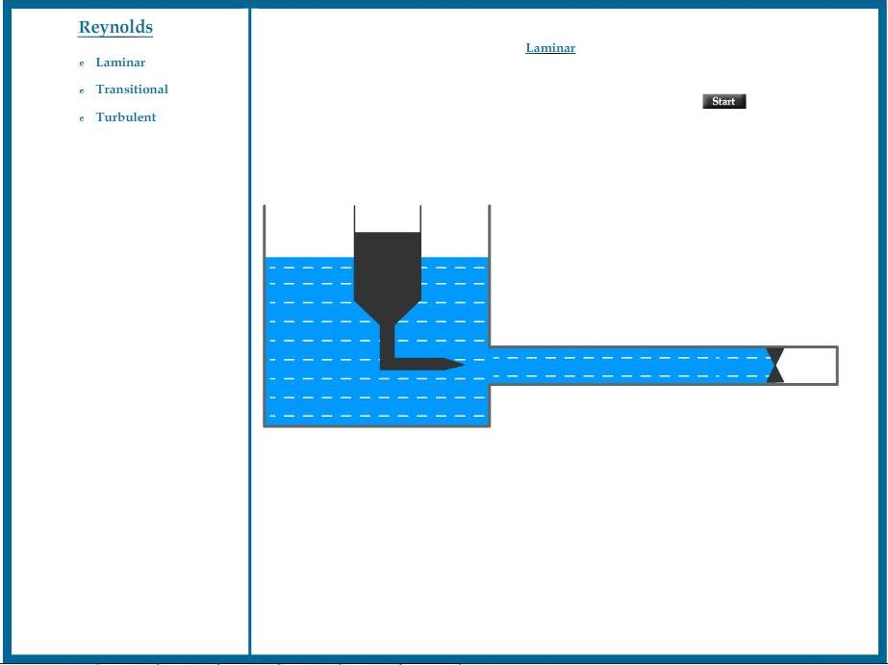

PART – 3
VIRTUAL LAB FRAME

